Types of Bonding Interactions Covalent bond
Ionic bond
Hydrogen Bonding
Hydrogen bonding, interaction involving a hydrogen atom located between a pair of other atoms having a high affinity for electrons; such a bond is weaker than an ionic bond or covalent bond but stronger than van der Waals forces.
.It explains some of the unusual properties of water such as its relatively high boiling point. It is also important in describing the structures of proteins and nucleic acids Hydrogen bonds can exist between atoms in different molecules or in parts of the same molecule. One atom of the pair (the donor), generally a fluorine, nitrogen, or oxygen atom, is covalently bonded to a hydrogen atom (―FH, ―NH, or ―OH), whose electrons it shares unequally; its high electron affinity causes the hydrogen to take on a slight positive charge. The other atom of the pair, also typically F, N, or O, has an unshared electron pair, which gives it a slight negative charge.
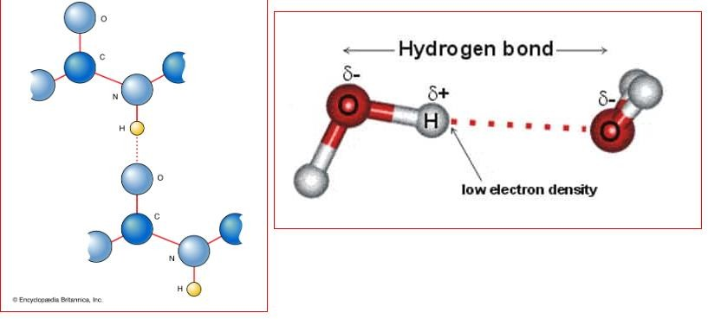

Van der Waals Forces
It is a distance-dependent interaction between atoms or molecules. Unlike ionic or covalent bonds, these attractions do not result from a chemical electronic bond; they are comparatively weak and therefore more susceptible to disturbance.
The van der Waals force quickly vanishes at longer distances between interacting molecules.

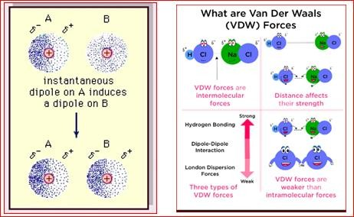

Coordination Compounds and Complexation
A coordination complex consists of a central atom or ion, which is usually metallic and is called the coordination centre, and a surrounding array of bound molecules or ions, that are in turn known as ligands or complexing agents.
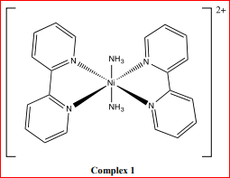

Many metal-containing compounds, especially those that include transition metals (elements like titanium that belong to the Periodic Table's d-block), are coordination complexes.
Metallic cations, especially the transitional metals are able to form stable compounds with additional anions or molecules with lone pair(s) of electrons, (ligands) to form complexes.
The maximum number of sites of the central metal occupied is called the coordination number.

The metal and its associated ligands are called the complex ion. The later with its counter ions is called the coordination compound.

Notes:
- the atom within a ligand that is bonded to the central metal atom or ion is called the donor atom
- polydentate (multiple bonded) ligand is a molecule or ion that bonds to the central atom through several coordination bonds. ligands with 2, 3, 4 or even 6 bonds to the central atom are common.
- These complexes are called chelate complexes; the formation of such complexes is called chelation, complexation, and coordination.
- Coordination refers to the "coordinate covalent bonds" (dipolar bonds) between the ligands and the central atom.
- The number of donor atoms attached to the central atom or ion is called the coordination number
- The stability of a complex depends on the metal ion and the basicity of the ligand, Lewis’s concept.
- Ligands can be bidentate, tridentate, tertradentate, hexadentate or octadenate
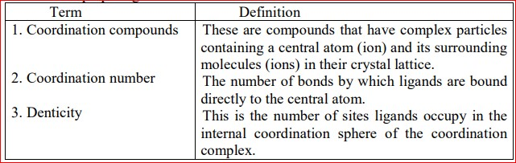

WE NEED A CENTERAL ATOM WITH d or f ORBITALS AND A LIGAND WITH UNBONDED ELECTRON PAIR

Formation of complexes in biological systems
A great many compounds in nature are classified as coordination compounds because of their structure, properties and biological activity. Metal-containing enzymes, hemoglobin, myoglobin, vitamin B12 are biologically active coordination compounds

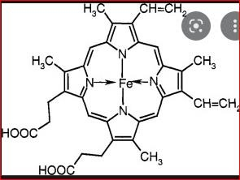
A specific group of compounds, that are able to form complexes with many cations, is widely used to dissolve stones in the kidneys and the gall bladder. They are used as stabilizers in blood conservation, because they bind the metal ions, which catalyze oxidation reactions. They are also used to remove ions of toxic metals and radioactive isotopes from the organism.

Complexes and Chelating Agents
An important feature of ligands is their denticity or the number of places occupied by the ligand in the internal sphere. When bidentate ligands are coordinated around the complexing agent, it results in formation of cyclic complexes. In such complex, a ligand and the complexing agent form a closed cycle due to bonds marked by arrows:
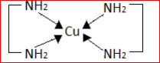
Chelating agents are important aspects of pharmacy, drug therapy. They have much efficacy in the treatment of heavy metal poisoning for elements such as lead, arsenic, mercury and iron.
Chelating agents are important in treatment of metabolic disorders where metals such as iron and copper are accumulated in abnormal amounts in various tissues.
Examples of important chelating agents include EDTA, BAL, penicillamine and deferoxamine.

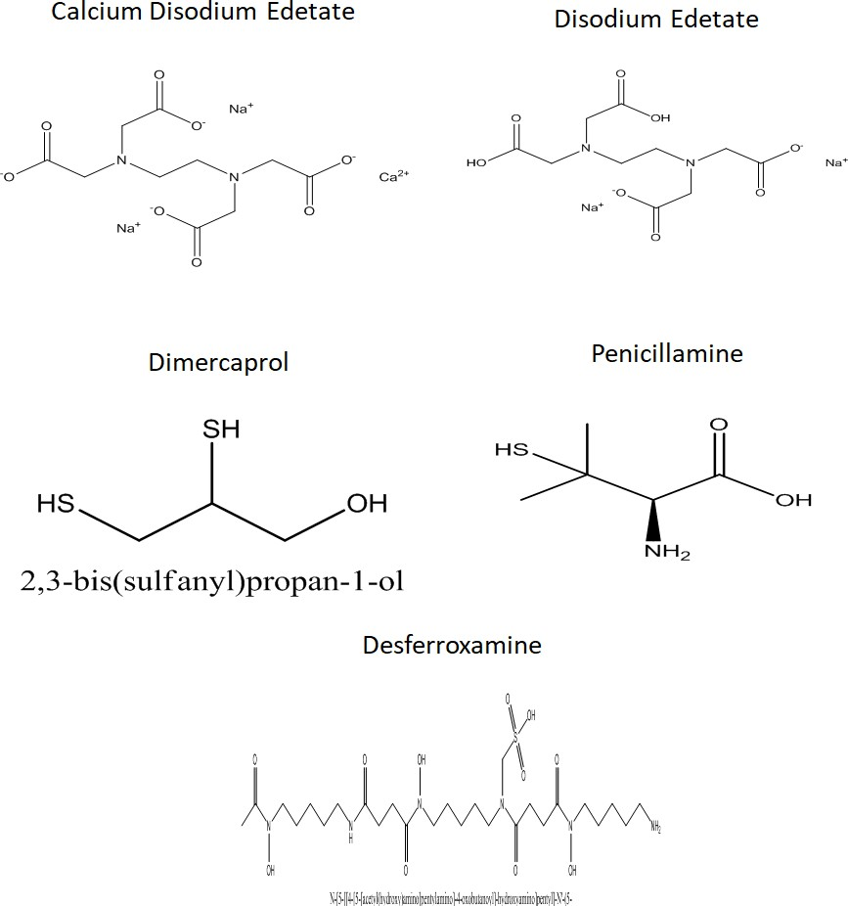

Calcium Disodium EDTA
The disodium salt of EDTA is a mixture of the dihydrate salt.
It is used in the treatment of heavy metal poisoning especially plumbsim (lead poisoning) and other metals but not for mercury, arsenic or gold. Why? It induces hypocalcaemia states.
Doses are IV or IM of 75mg/kg of body weight. Preparation; a solution containing 200mg/ml for injection.

Disodium Edetate
It is used in treatment of conditions related to hypercalcemia including occlusive vascular disease and cardiac arrhythmias. It is not useful for dissolution of urinary calculi.
t is used to treat calcium overload. It is also used to treat irregular heart beats caused by too much digitalis (digoxin or digitoxin).
Doses; IV injections of 50mg/kg of body weight. Preparation; 150mg/ml for injection.

Dimercaprol (BAL)
It is a colorless of mercaptan-like odor. It competes with enzymes containing sulfhydryl groups (responsible for oxidation-reduction) for the metals causing poisoning.
The mercatides formed are excreted in the urine.
BAL is of value in the treatment of arsenic or gold poisoning and early mercury poisoning, within a few hours.
Dose: in severe arsenic or gold poisoning , 3.0mg/kg is given six times a day for two days, four times a day on the third day, then twice daily on the next ten days.
For early mercury poisoning, 5.0mg/kg followed by 2.5mg/kg twice daily for ten days.
Preparations: IM imgectio of 100mg/ml in peanut oil.

D-Pencillamine
Pencillamine is used for treatment of poisoning of many metal including lead, iron, mercury and gold.
Pencillamine is is used for treatment of hepatolentecular degeneration (degeneration of the brain associated with increased levels of copper and Wilson’s disease which is associated with elevated levels of copper in tissues including; eye, liver, brain and kidney.
Pencillamine is used in the treatment of gold dermatitis.
Pencillamine is used in the treatment of cystinurea, the presence of crystals of cystine in urea.
Dose: 250mg capsules given four times a day.
Preparations: Cuprimine capsules containing 250mg of penicillaime for oral administration.

The effectiveness of pencillamine as compared to other antidote for treatment of copper toxicity is attributed to
- Ability to resist metabolic inactivation by AA oxidase since it doesn't have a hydrogen on the beta carbon atom.
- its sulfhydryl group has the ability to convert Cu⁺² to Cu⁺, with the formation of a tetrahedral rather than a square planar complex which has less affinity in competition with the tissue proteins containing –SH groups of oxidative value.

Deferoxamine mesyalte
Deferoxamine is for acute iron toxicity.
It forms an octahedral complex with Fe⁺³. It has no affinity to divalent ions including Fe⁺².
Deferoxamine is not soluble in the gastrointestinal tract so oral administration is not effective.
It is produced by streptomyces as a ferric Fe(III)complex. After chemical removal of the iron, the chelating agent is purified as the methyl sulphonate salt.
Dose: IV or IM injections of 1.0g followed by 0.5g every 4-12 hours. Preparations: Desferal ampules containing 500mg of the lyophilized powder for injection.

